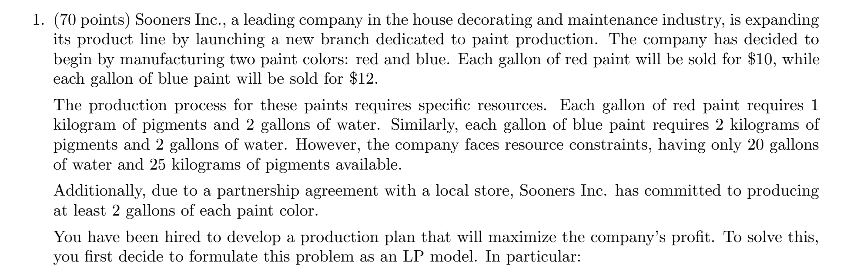
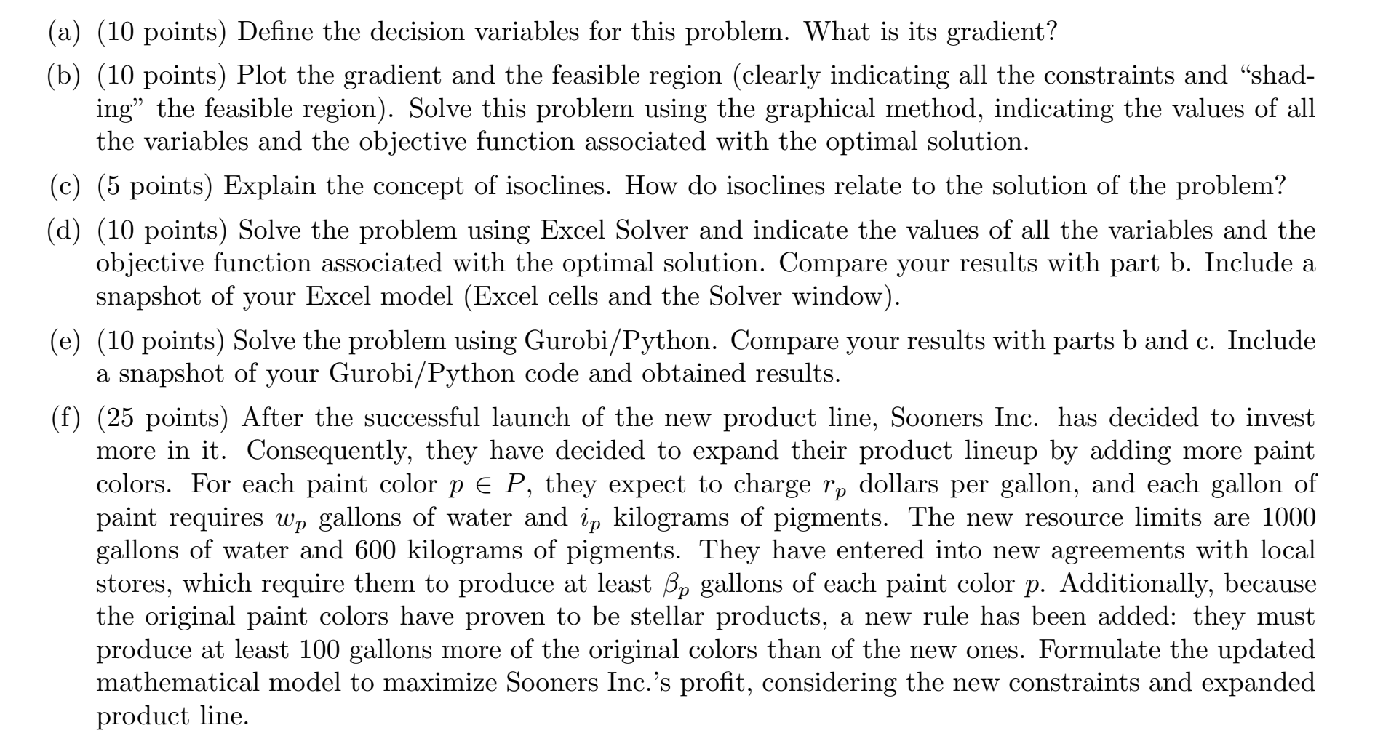
Juan Mejia Homework 2

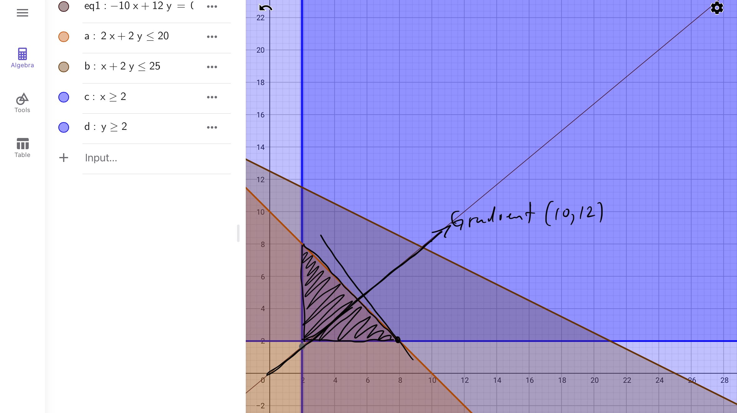
Figure 1. Model 1 graphical solution using geogebra.

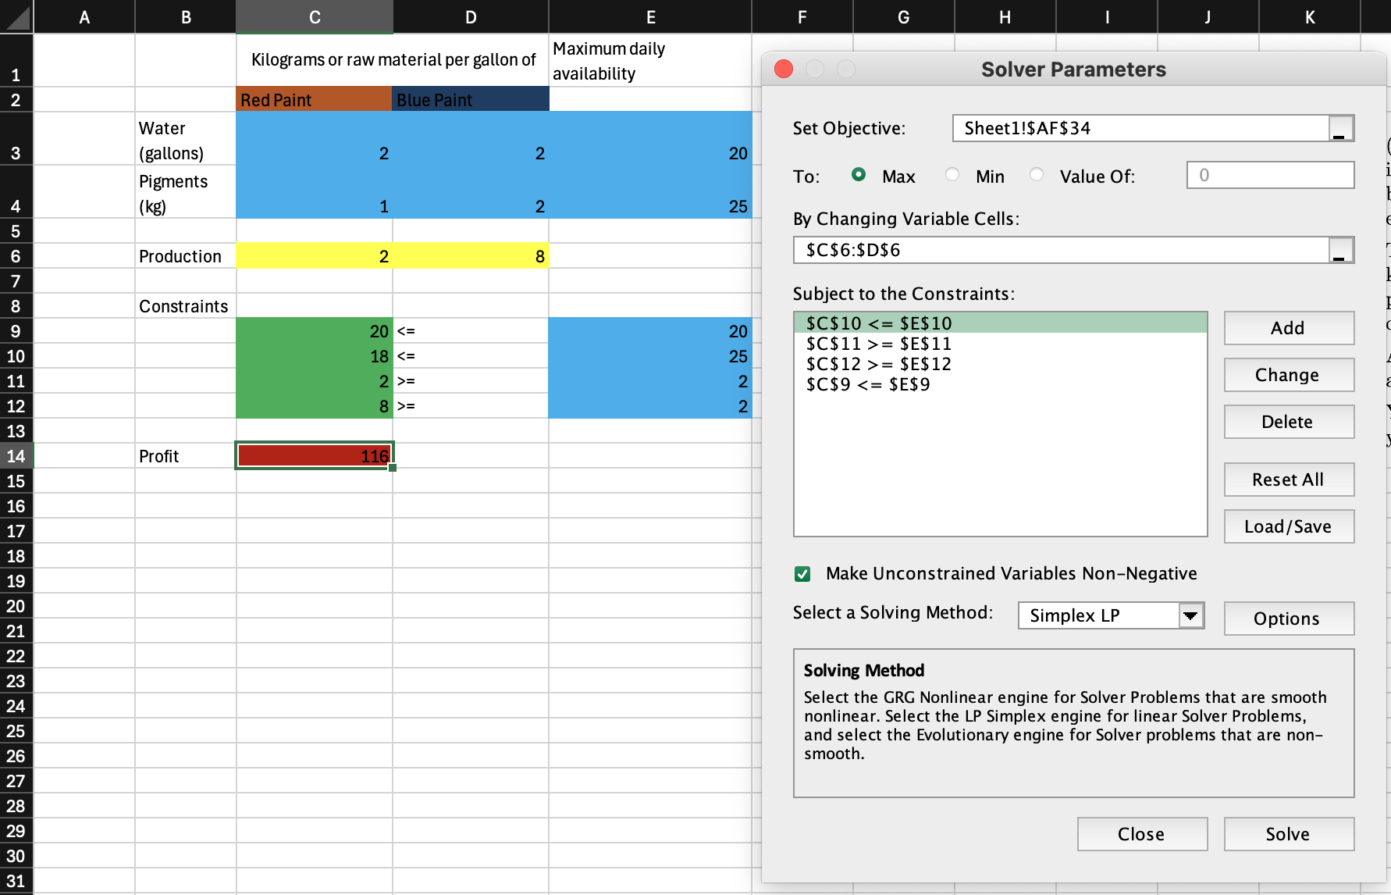
Figure 2. Model and solution for problem 1 using Excel solver

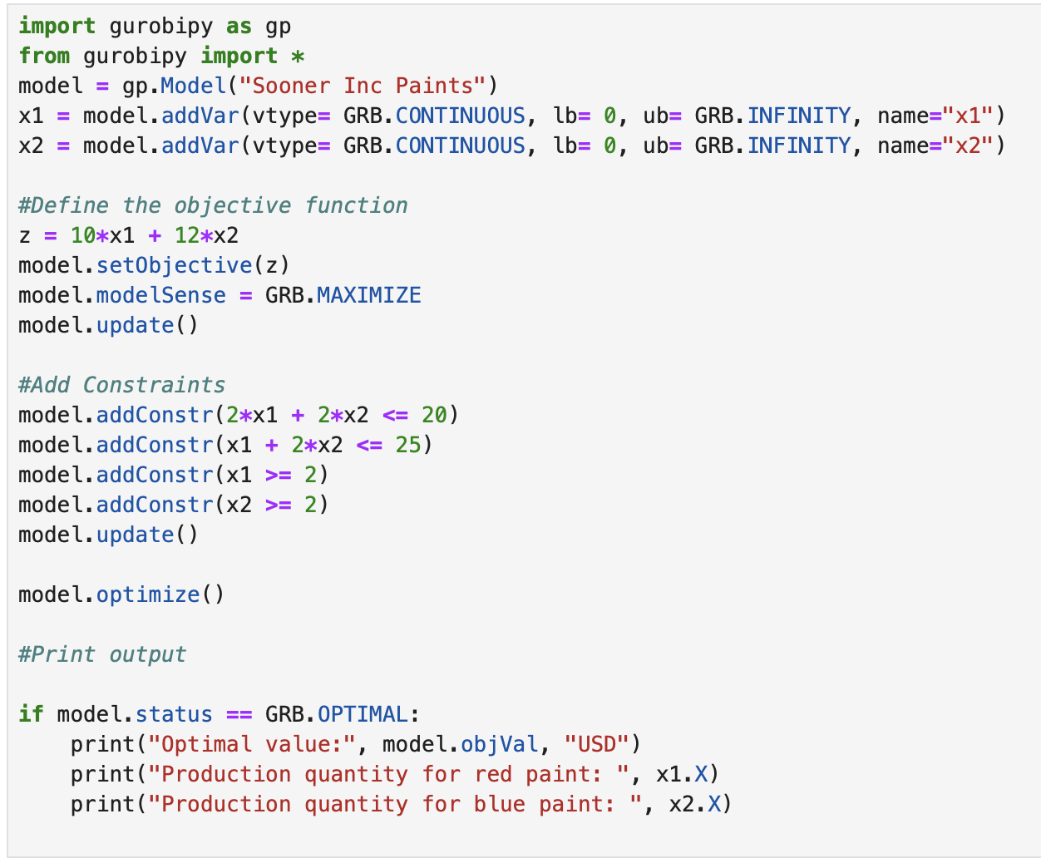
Figure 3. Model 1 in gurobi

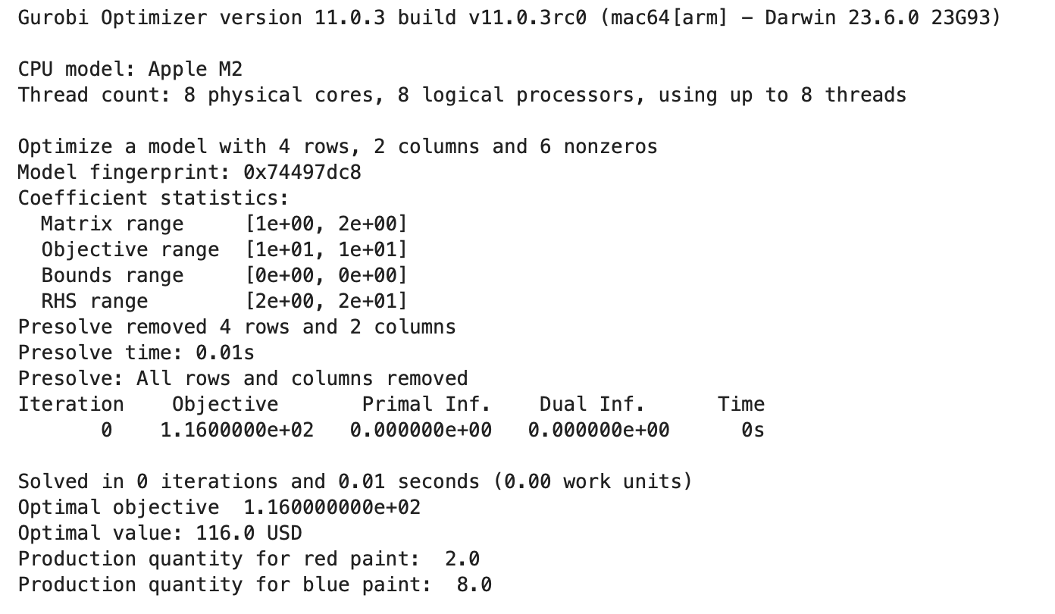
Figure 4. Solution for model 1 in gurobi

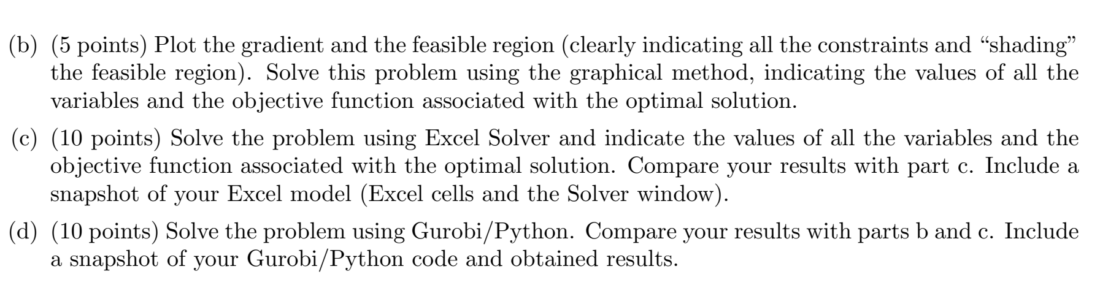
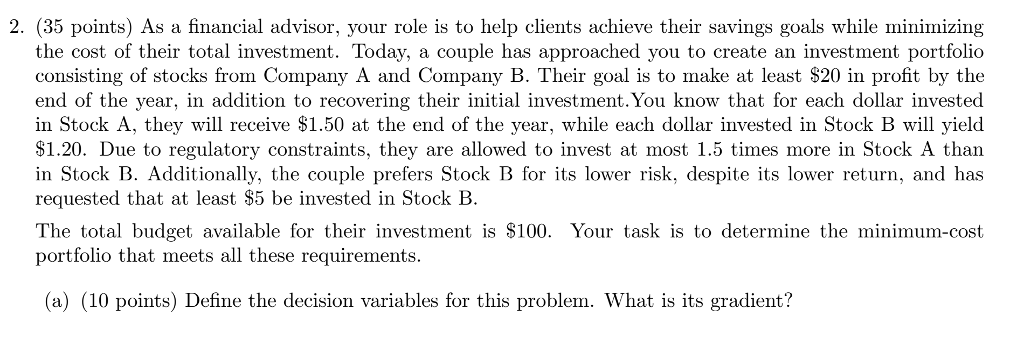

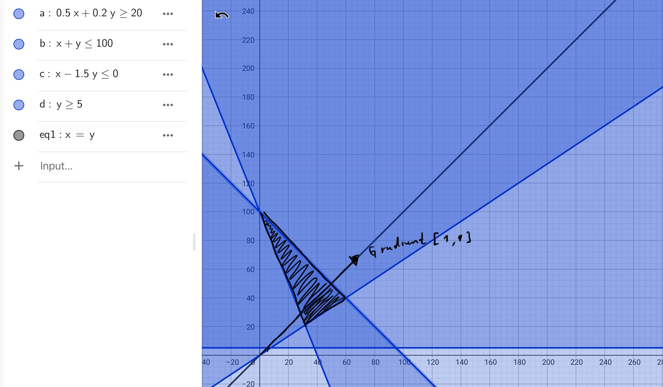
Figure 5. Model 2 graphical solution using geogebra.

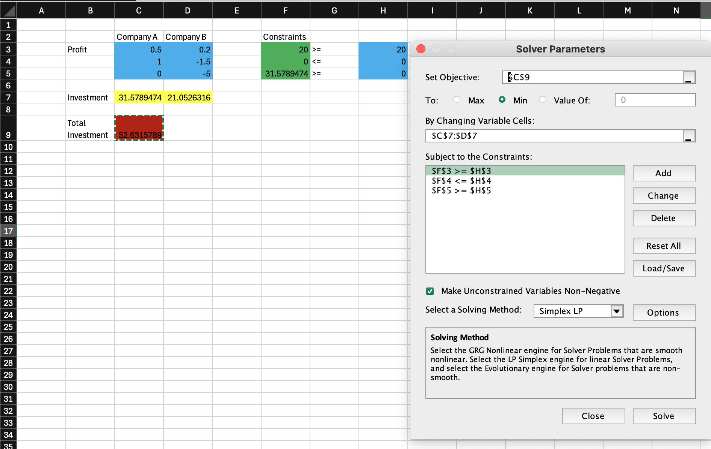
Figure 6. Model and solution for problem 2 using Excel solver

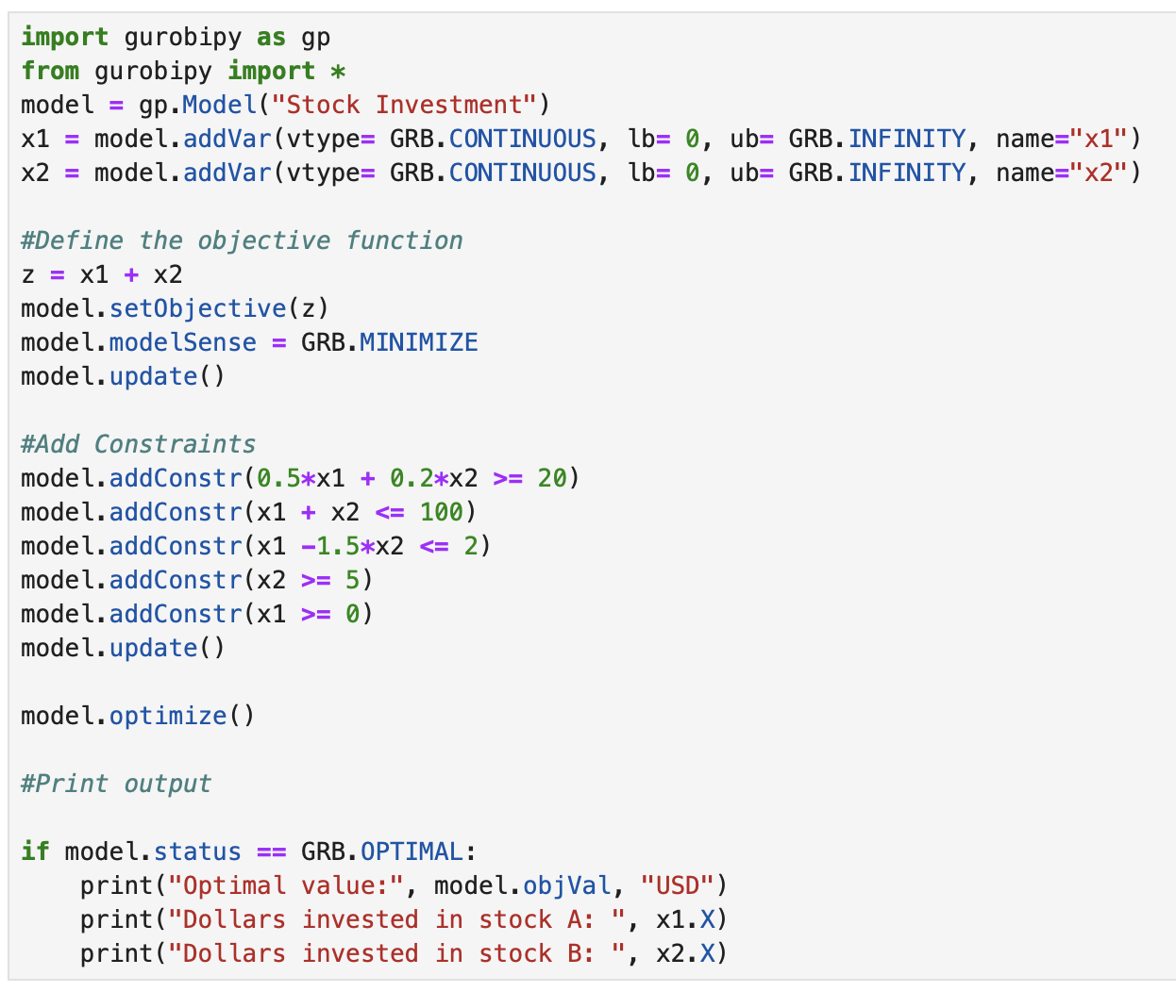
Figure 7. Model 2 in gurobi

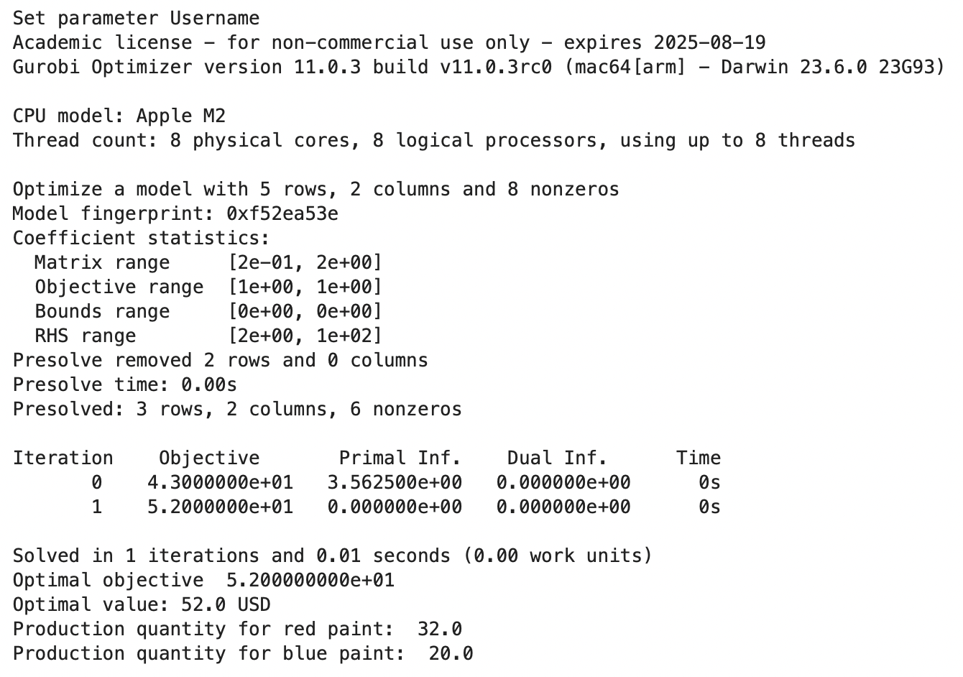
Figure 8. Solution for model 1 in gurobi

